Site Registration - Girl 13 and Older

Previous Steps: Site Registration


After agreeing to Terms and Conditions, you will be prompted to register all girls associated with your email address. Enter their preferred first names.

If the girl is over 13, you have the option to also enter an email address for that girl so she can manage her digital cookie site herself.

If your Girl Scout over 13 doesn’t have her own email address, you can create one and not share the password with her—simply use it to access the registration emails for the Digital Cookie site. It can’t be the same email address used for anyone else, such as a parent or another girl.

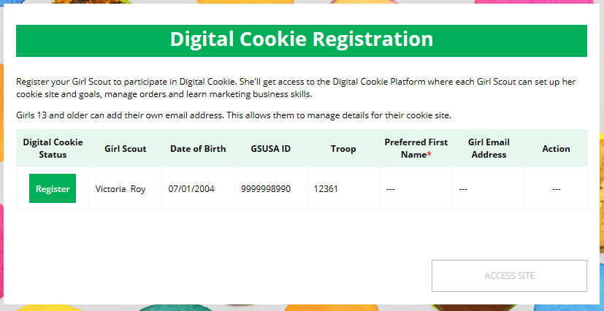
Click to Register

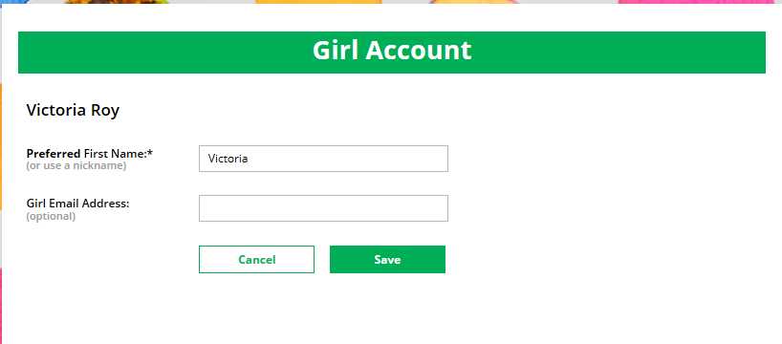
Enter Girl Email Address
(optional)


The girl will then need to check her email inbox for an email from “Girl Scout Cookies”. Girls should be sure to add email@email.girlscouts.org to their “safe senders” list so that this email goes to their inboxes and not to junk/spam/promotions email folders.

When she gets the email, she simply clicks on the green button to be sent to the Digital Order Card website where she will be able to set her password.



Click “Register Now”

If she does not get the registration email within 15 minutes of you adding her email address, girls can follow the steps on the “No Registration Email” Tip Sheet.


The Girl Scout will need to complete the same steps to set up a password that her parent completed. Once she has set her password, she will be taken to the Safe Selling for Smart Cookies video. She can’t proceed further until the full video has been viewed.



Then, read the “Girl Scout Safety Pledge.”

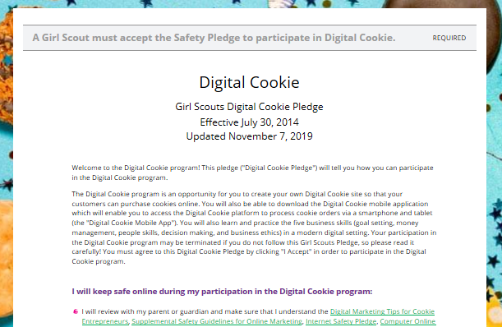

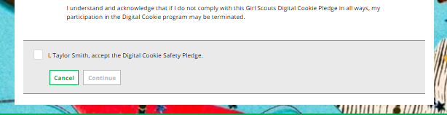
Accept
Continue

After she has read the pledge, she can click the box to accept it and then click “Continue” be taken to the home page of her site to set it up.

Next steps: Site Setup-Girl 13 and Older
Marketing to Customers

